

Seeking Postdoctoral Fellows in Affective, Cognitive, & Aging Neuroscience
The MIDUS Affective Neuroscience Project team led by Dr. Stacey M. Schaefer at the University of Wisconsin-Madison’s Institute on Aging is seeking a postdoctoral scholar to analyze and publish on neuroscience data from the national longitudinal Midlife in the US study. MIDUS is an NIA-supported study on aging explicitly focused on all the adult years (25-100+) with multiple longitudinal timepoints over the past +20 years. This is an opportunity to become part of a scientific community that is actively engaged with MIDUS and play a key role in analyzing neuroimaging data in relation to affective, psychophysiological, sociodemographic, behavioral, cognitive, biomarker, and environmental data with an emphasis on understanding the factors that are important for emotional wellbeing, brain health, and brain aging.

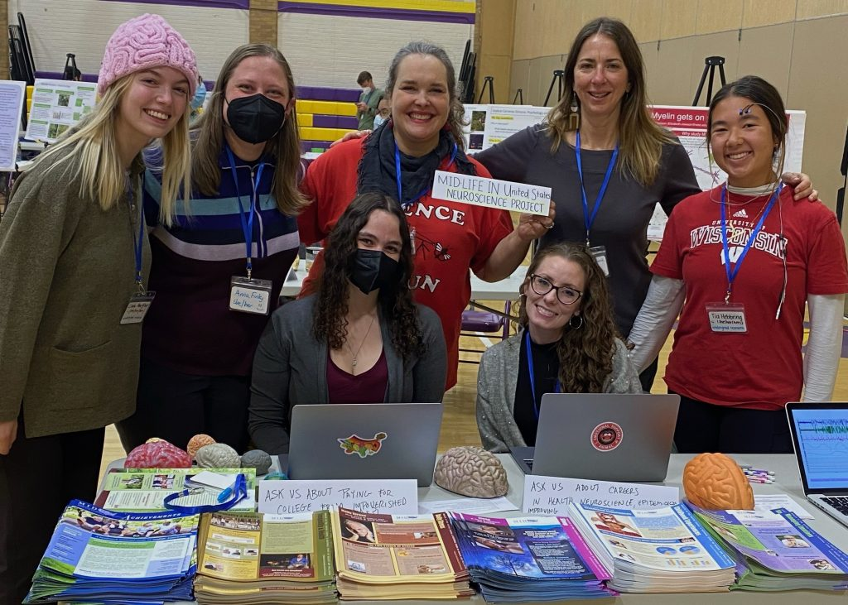
This fully supported appointment provides a broad, interdisciplinary experience preparing postdoctoral researchers to generate new discoveries of what happens to people, their emotional processes, and their brains as they age and to determine what contributes to health and well-being vs. vulnerability to pathology and cognitive decline. Training and support include the ability to attend relevant seminars and courses, training and mentorship in grant writing, introduction and exposure to an extensive collaborative network, and the opportunity to mentor undergraduate researchers’ independent projects and participate in community outreach.

Responsibilities:
- Participates in planning, designing, and conducting highly technical and complex research projects under the direction of a supervising mentor.
- Analyzes and evaluates research data.
- Prepares papers and research documentation for publication.

Requirements:
- Ph.D. in Neuroscience or Psychology (or directly relevant field).
- Experience with functional (task, resting), diffusion weighted, perfusion, &/or structural imaging data.
- Statistical acumen in analyzing neuroimaging data and programming expertise.
- Experience in scientific communication including speaking and publishing.
- Excellent organizational, project management, interpersonal, writing and communication skills.
- Adaptable; self-motivated.

Preferred:
- Experience in neuroimaging research in emotion, cognition, and/or aging.
- Experience with psychophysiological data including facial electromyography, heart rate variability, skin conductance, pupillometry, and/or eye tracking.

Additional information: Expected position duration is two years with potential for renewal based on funding and performance. Past and current MIDUS Neuroscience postdocs have been highly successful in obtaining NRSA Postdoctoral Fellowships to extend their training experience. Visit the MIDUS Affective Neuroscience Project website to learn more and the MIDUS website to learn more about MIDUS in general.

To apply please send cover letter and CV to: Stacey M. Schaefer, Stacey.Schaefer@wisc.edu
UW-Madison is an equal opportunity/affirmative action employer. Qualified individuals are encouraged to apply.



